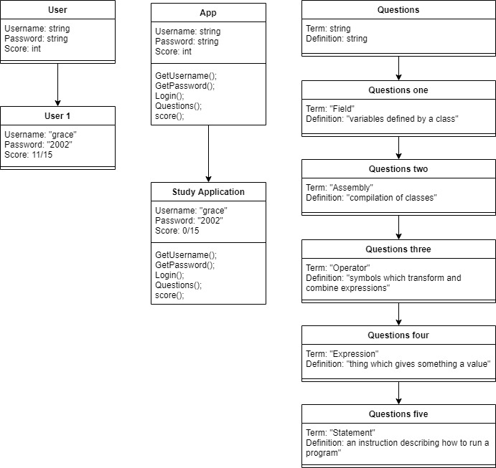

I didn’t change anything that would adjust this UML. To implement the use of a text file, I displayed the terms and definitions using the .txt file to do so. Which was cleared when the questions began.